Data Analysis Report – Part B

Introduction
The aim of the project is to develop a model to predict whether a company is bankrupt. Accuracy of predictions is the most important factor, but understanding the impact of the variables on the predictions is also to be considered. I have fit a logistic regression model to the data as has been done already and compared it with an explainable boosting machine model, chosen as a result of the findings from fitting a logistic regression model.

Data Analysis

Data
Initial data checks were performed using the package ydata-profiling (Clemente et al., 2023), which allowed me to go through all of the variables and check for errors and understand their compositions better. Confirming the following:
- There are 96 variables, 4091 observations.
- All variables are numeric, some of which are binary.
- There are no duplicate observations.
- No variables have missing entries.
- ‘Net Income Flag’ has a constant value of 1 so it was removed.
- The target variable “Bankrupt?” has 96.9% zeros.
- Some columns appear spurious as they have the majority of values in the column between 0 and 1 and then some as high as a few million, these appear to be supposed to be a rate so if the majority of cases are between 0 and 1 assume that this is the correct range. To decide whether to remove the whole column or whether you can just take out some observations that are spurious in multiple columns. I isolated the columns where the majority (90%) of values are between 0 and 1 but there are still values above 1000 and found 15 columns.

Logistic Regression Model

Preprocessing
As this is a financial dataset and many of the columns are rates or ratios, I concluded that the extremely high values will result from having near zero denominators. This is common in financial datasets and can be mitigated for using winsorisation as stated in Fama and French (1992). This means that the bottom 1% and top 1% of values are replaced with the values at the 1st and 99th percentiles. I created the threshold for the windsorising from the training set and applied these thresholds to both the train and test set. Importantly I did not recalculate these thresholds using the test set.
Only a small proportion of the observations have information on bankruptcy (126 1’s). Therefore, the events per variable for bankrupt is roughly 126 / 96 ~ 1.3 which is significantly lower than the recommended score of > 10 recommended by Peduzzi et al. (1996) for logistic regression. Therefore, dimensionality reduction is needed.
For my first iteration of the model, I split the data into a train and a test split. I chose to do the holdout method initially so that I could explain all of the steps taken in this report, as well as providing a training set to use to decide between preliminary logistic regression models. Because there are so few instances of bankruptcy, the test split was made larger than usual at 30%, to ensure enough instances of bankruptcy would be in it.
To reduce dimensionality, the first thing that can be done is identify correlated variables using the VIF scores. This has to be done after splitting into a train and a test split to stop data leakage (Amit Moscovich and Rosset, 2022). I wrote a function that iteratively removes the variable with the highest VIF score until all VIF scores are less than 5. This reduced the number of variables from 95 to 29.
To get closer to ~12 variables, I fit a LASSO regression to the training set to identify the most important variables. This is an L1 regularisation technique that penalises variables with less statistical predictive power, which are the ones without a coefficient of 0. The regularisation parameter chosen for this was 0.07, this was selected by optimising over values from 0.01 to 10 to achieve the most accurate model. A lower value of C means the model punishes the least important variables further. LASSO regression is chosen over stepwise selection techniques as they can produce unstable models and biased coefficient estimates (Steyerberg et al., 2001). This resulted in a final model containing ten predictors, satisficing the recommendation set in Peduzzi et al. (1996) .

Model fitting

After this, the initial logistic regression model was fitted. Four predictors and the constant were not individually statistically significant (had p-values greater than 0.05) in the Wald test, to check the variables are not zero. However, they were retained to maximise predictive performance as is shown in Kattan (2003).
Table 1: Coefficients and p values of Wald significance test of coefficients in untransformed model.
Variable | Coefficient | P value
const | 69.7221 | 0.008
operating_expense_rate | 7.88E-11 | 0.039
tax_rate_a | -2.6038 | 0.102
accounts_receivable_turnover | -167.54 | 0.028
fixed_assets_turnover_frequency | 8.83E-11 | 0.050
allocation_rate_per_person | 11.5329 | 0.015
retained_earnings_to_total_assets | -31.0028 | 0.000
total_expenseassets | 11.5146 | 0.060
equity_to_longterm_liability | 11.6641 | 0.416
net_income_to_stockholders_equity | -51.4912 | 0.122

I tested the linearity assumption of logistic regression models using the Box-Tidwell test. I wrote a function to perform the test iteratively, by transforming each variable to go from x -> x*log(x) and adding it to the variables before running the model and checking the p-value. I concluded that 2 of the variables failed the test. To resolve it I tried to transform the variables. Because we are using financial data and I noticed that a lot of the variables distributions are very skewed, I used a log transform.
Table 2: Results of the Box-Tidwell test for linearity of the variables in the logistic regression model.
Variable | p_value | Conclusion
allocation_rate_per_person | 0.00 | Fails linearity assumption
equity_to_liability | 0.00 | Fails linearity assumption
retained_earnings_to_total_assets | 0.10 | Passes linearity assumption
accounts_receivable_turnover | 0.37 | Passes linearity assumption
net_income_to_stockholders_equity | 0.69 | Passes linearity assumption
tax_rate_a | 0.72 | Passes linearity assumption
fixed_assets_turnover_frequency | 0.73 | Passes linearity assumption
equity_to_longterm_liability | 0.78 | Passes linearity assumption
total_expenseassets | 0.82 | Passes linearity assumption
operating_expense_rate | 0.99 | Passes linearity assumption

This did not succeed in solving the linearity problem for either variable. Consequently the non-linear variables were removed to see if it would improve performance against the other two models. It reduced the ROC-AUC score from 0.95 to 0.87 and the precision from 0.47 to 0.33. I prioritised precision scores because of the low proportion of bankrupt cases. Because a key function of the model was predictive power, and because of the reduction as a result of this, I decided to compromise on ensuring linearity and accept the model with greater predictive power. Therefore, I chose to still include non-linear variables in the final model.
Table 3: Performance scores of the three possible logistic regression models: one with all variables that were significant after LASSO regression, one where the variables that failed the Box-Tidwell test of linearity had been log-transformed and one where the variables that failed the Box-Tidwell test of linearity had been removed.
 | Original Logit | Logit with log transforms for non-linear variables | Logit with non-linear variables removed
ROC-AUC | 0.95 | 0.95 | 0.87
accuracy | 0.97 | 0.97 | 0.96
precision | 0.47 | 0.47 | 0.33

Without the log transforms the model coefficients are more explainable. The model with log transforms (but no variables removed) performed the same as the model without log transforms (and still failed the linearity test), so I stuck with the model without log transforms. Therefore, the final logistic regression model is:
$$\log\left(\frac{p}{1-p}\right)=69.7221 +7.884×{10}^{-11} operating_expense_rate -2.6038 tax_rate_a -167.54 accounts_receivable_turnover+8.825×{10}^{-11} fixed_assets_turnover_frequency+11.5329 allocation_rate_per_person-31.0028 retained_earnings_to_total_assets+11.5146 total_expensesets+11.6641 equity_to_longterm_liability-51.4912 net_income_to_stockholders_equity-119.8899 equity_to_liability$$
This can be read such that, if the $allocation_rate_per_person$ increases by 0.1, then the log odds of bankruptcy increase by around 1.1. This would mean that the actual odds of bankruptcy increase by $e^{1.1}$~ 3 times. Similarly for the variables with negative variables, an increase in the value of $net_income_to_stockholders_equity$ by 0.1 decreases the log odds by around 12 which means that the odds of bankruptcy are multiplied by $e^{-12}$~ $6.14×{10}^{-6}$ times, reducing the odds by around roughly 99%.

Model validation
I checked the independence of observations through the deviance residual series plot. No clear trends emerged to I was satisfied that the observations are independent. I was also happy that the sample size was sufficiently large, but the lack of observations that are bankrupt does limit the predictive power.
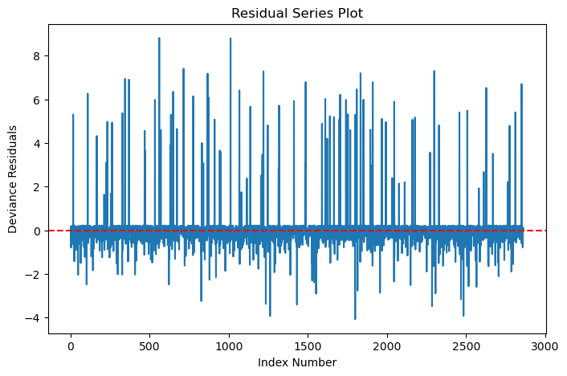
Figure 1: Residual plot of the observations against their index.
I then investigated, within my training set, the influential points. 4.2% of points were deemed highly influential (a Cook’s distance greater than $4 / \# of observations in the training set$). Influence does not imply error. And in financial datasets it can be quite common to have influential points with correct anomalous information. So, they are kept in with a recommendation for further investigation. The influential points are the ones with the largest Cook’s distance in figure 2.
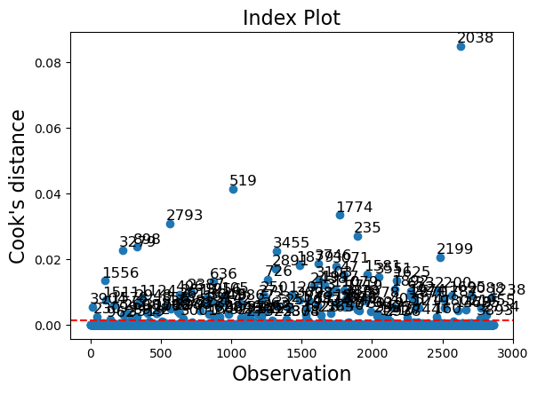
Figure 2: Plot of Cook's distances, a measure of the influence, of the observations.

Explainable Boosting Machine Model

What is an Explainable Boosting Machine
As the tests on the logistic regression model suggest, the relationship between the target variable and the prediction variables is not linear. The logistic regression also warns that there is possible complete quasi-separation. Indicating that 18% of the variables can be perfectly predicted by a single variable, which also makes the logistic regression unstable. Therefore, I wanted to use a model that didn’t have a linearity assumption.
I decided to try another Generalised Additive Model (GAM) called an Explainable Boosting Machine (EBM) because it has high predictive power, maintains interpretability and does not require any distributional assumptions. It is a linear combination of piecewise and pairwise functions of variables, but these functions do not have to be linear.
Traditional GAM’s (logistic regression is a form of this) were powerful but struggled with the relationships between variables. EBM’s were introduced in Lou et al. (2013) as an answer for improving model performance by adding the pairwise interactions between variables to regular GAM’s. This allows for variables to be correlated. EBM’s require a large amount of compute and can’t scale to massive datasets, which is why with this relatively small dataset it is a good option, but should be noted for the future.

The model has the general form provided by Lou et al. (2013) of
$$g\left(E\left[y\right]\right)=\sum_{i}{f_{i}\left(x_{i}\right)}+\sum_{i<j}{f_{ij}\left(x_{i},x_{j}\right)}$$
- $g\left(∙\right)$ — link function (e.g. logit for classification).
- $E[y]$ — expected value of the target variable.
- $f_{i}(x_{i})$— learned shape function for feature $x_{i}$.
- $f_{ij}(x_{i},x_{j})$— learned pairwise interaction function between pairs of features $x_{i}$and $x_{j}$.
As you can see by the summations, the total model is a linear combination of functions. Each function is learned using boosted decision trees applied to discretized feature bins (Nori et al., 2019).

Preprocessing, model fitting and evaluation
As the model does not have to satisfy any assumptions, all variables in the dataset can be included in the model. As functions are non-linear, extreme values can be dealt with by these functions and don’t require transformations in the data.
I fit the model on the same train split as the logistic regression model using the interpret package developed by Nori et al. (2019). It allows you to observe the functions that contribute to the overall probability scores, and it computes feature importance scores.
EBMs provide a feature importance score, that considers the scale but importantly does not require the variables to be scaled. For the logistic regression you have to either compromise explainability of the individual effects of real-world changes in variables or their importance. By scaling the variables, you can deduce the feature importance but can’t see how the likelihood changes with single increments of each variable. If you don’t scale the variables as I did, you can explain the impacts of changes on the likelihood but can’t deduce feature importances from the coefficients as variables with larger scales will have larger variables.
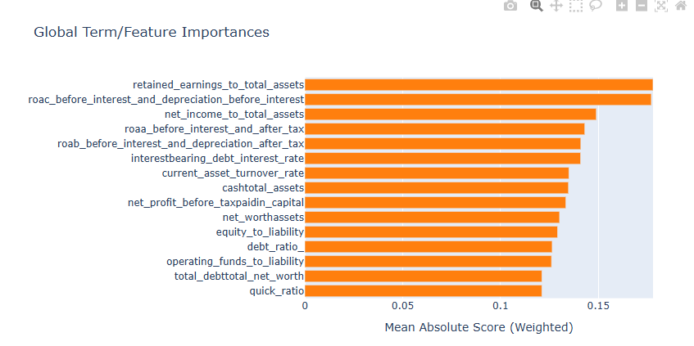
Figure 3: Feature importance scores of the most importance features / combined features.
Feature retained_earning_to_total_assets is the feature with the most predictive power, so we can look at the functions in the model that involve it. From figure 4 you can see that this appears to be a step function, one that was possibly discussed in the logistic regression warning, that if the retained_earning_to_total_assets > 0.95 it is guaranteed to be bankrupt. 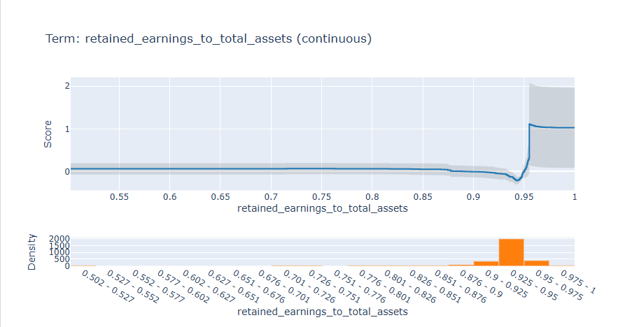
Figure 4: Additive function including just the retained_earnings_ratio_to_total_assets variable. Continuous function graph as well as histogram of counts below.
Comparatively, the second most important term roac_before_interest_and_depreciation_before_interest has a smoother distribution for its function. The majority of values are between 0.45 and 0.57, and in this range, as your score in this variable increases your likelihood of bankruptcy decreases.
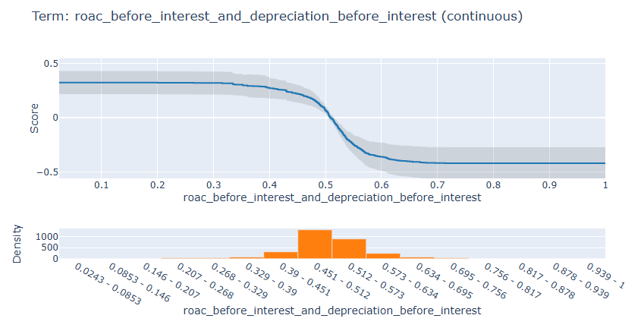
Figure 5: Additive function including just the roac_before_interest_and_depreciation_before_interest variable. Continuous function graph as well as histogram of counts below.
No pairwise combination of variables was included in the most important features indicating that the relationships between the variables don’t provide as much predictive power as individual variables.

Model Comparison
So, we’ve understood what each of the models is telling us. Now we want to compare which one is more accurate at predicting bankruptcy. Of the 15 most important features in the EBM model, only two of them are in the logistic regression model. Interestingly, the most powerful predictor, retained_earnings_ratio_to_total_assets, is in both models. Equity to liability is also in both models, and those two variables were the only two to have significances of 0.00 in the Wald test of the logistic regression model, indicating that these are two robust predictors.
To compare the model performances, 3-fold cross validation is used, I originally wanted to do 5-fold cross validation, but this would not allow large enough test sets. K-fold cross validation avoids possible overfitting that comes as a result of the model randomly performing well on the test set. The preprocessing steps for both models all happen on each of the 3 training sets. This ensures that you don’t get data leakage from the 5 test sets (Amit Moscovich and Rosset, 2022), therefore each of the 3 logistic regression models may have different variables in. The 3 train test splits of observations are constant due to setting the random state.
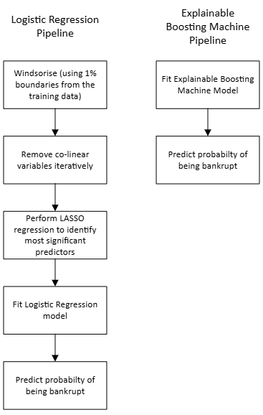
Figure 6: Fit, predict pipelines that the training and test splits go through for the respective models.
After the 3-fold cross-validation, figure 7 shows that the EBM had a higher score in all metrics tested. This was particularly true for ROC-AUC score and precision which were the main models of interest. A precision score of 0.565 shows that it correctly identifies over half of the bankrupt cases compared with the logistic regression model which identifies less than half (44.6%). The model is also consistently better as the ROC-AUC and precision scores have a smaller standard deviation. Having an ROC-AUC score 4 percentage points higher means the model correctly ranks a bankrupt firm above a non-bankrupt firm 94% of the time, compared to 90% for the logit model. The accuracy scores are so high because both models correctly predict that the majority of companies are not bankrupt, so accuracy is not as useful a measure of performance in this case.

Figure 7: Average performance scores across the 3 cross validation folds. Error bars are the standard deviation.
Table 4: Average and standard deviation of the performance scores across the 3 cross validation folds.
 | Logit |  | EBM
 | Average Score | Standard Deviation | Average Score | Standard Deviation
ROC-AUC | 0.905 | 0.033 | 0.943 | 0.014
accuracy | 0.968 | 0.001 | 0.971 | 0.001
precision | 0.446 | 0.041 | 0.565 | 0.024
recall | 0.143 | 0.034 | 0.230 | 0.058
f1-score | 0.215 | 0.043 | 0.324 | 0.058

Conclusion
I recommend that the explainable boosting machine should be used to predict company bankruptcy going forward. This model allows you to understand the relationships, which have been proven to be non-linear, between the predictor variables and the target. It has stronger predictive power than a traditional logistic regression, it requires a less complex modelling pipeline, and you can accurately determine which variables are the most influential indicators for further research. However, the logistic regression model performed almost as well, is slightly less complex to explain mathematically to business stakeholders and its commonality within business may mean greater adoption. This should be communicated to decision makers.
The data has a limited number of bankrupt observations with reduces the confidence with which estimations can be made and models can be compared. Therefore, accessing a greater amount of data would be a priority for further evaluation.

Bibliography
Amit Moscovich and Rosset, S. (2022). On the Cross-Validation Bias due to Unsupervised Preprocessing. Journal of the Royal Statistical Society Series B (Statistical Methodology), 84(4), pp.1474–1502. doi:https://doi.org/10.1111/rssb.12537.
Clemente, F., Gonçalo Martins Ribeiro, Alexandre Quemy, Miriam Seoane Santos, Ricardo Cardoso Pereira and Barros, A. (2023). ydata-profiling: Accelerating data-centric AI with high-quality data. Neurocomputing, 554, pp.126585–126585. doi:https://doi.org/10.1016/j.neucom.2023.126585.
Fama, E.F. and French, K.R. (1992). The Cross-Section of Expected Stock Returns. The Journal of Finance, [online] 47(2), pp.427–465. doi:https://doi.org/10.2307/2329112.
Kattan, M. (2003). Book Review: Regression Modeling Strategies: With Applications to Linear Models, Logistic Regression, and Survival Analysis. By Frank E. Harrell Jr. New York: Springer-Verlag, 2001, 582 pages. Medical Decision Making, 23(2), pp.182–183. doi:https://doi.org/10.1177/0272989x03023002011.
Lou, Y., Caruana, R., Gehrke, J. and Hooker, G. (2013). Accurate intelligible models with pairwise interactions. Proceedings of the 19th ACM SIGKDD International Conference on Knowledge Discovery and Data Mining, pp.623–631. doi:https://doi.org/10.1145/2487575.2487579.
Nori, H., Jenkins, S., Koch, P. and Caruana, R. (2019). InterpretML: A Unified Framework for Machine Learning Interpretability. arXiv:1909.09223 [cs, stat]. [online] Available at: https://arxiv.org/abs/1909.09223.
Peduzzi, P., Concato, J., Kemper, E., Holford, T.R. and Feinstein, A.R. (1996). A simulation study of the number of events per variable in logistic regression analysis. Journal of Clinical Epidemiology, 49(12), pp.1373–1379. doi:https://doi.org/10.1016/s0895-4356(96)00236-3.
Steyerberg, E.W., Eijkemans, M.J.C., Harrell, F.E. and Habbema, J.D.F. (2001). Prognostic Modeling with Logistic Regression Analysis. Medical Decision Making, 21(1), pp.45–56. doi:https://doi.org/10.1177/0272989x0102100106.

